**Iceland 2020**

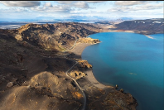**\*NEW* Reykjanes Peninsula Day**: This day takes a closer look at the ‘real Iceland’ away from the tourist hotspots. Visit Lake Kleifvatn to look at pillow lava the foundation of Iceland before stopping in the Seltun geothermal area, where the volcanic heat has formed thermal springs teams vents and mud pools. Make a brief stop at Graenavatn explosion crater before visiting Litli Eldborg: a crater serving lava flows with a visible lava tube. Later in the day, we will visit Gunnuhver hot spring area and then the stamper volcanic fissure, demonstrating the two hornitos together with Reykjanesviti – which is the home to Iceland’s oldest lighthouse, perched on top of a surseyan volcanic cone. The day concludes with a visit to the bridge over the Atlantic en-route to Reykjavik and the Perland Centre, which supplies Reykajavic with geothermally heated water.

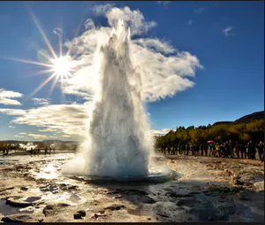**Golden Circle Day**: We study geothermal activity at truly spectacular locations. A visit to the Hellisheidi power plant where students will learn about how Iceland harnesses the heat from the Earth to generate electricity, then onto the Kerid volcano to walk around the crater. The famous Gullfoss waterfall is the next stop. We visit Strokkur (the most famous and active geysers in Iceland in action before a visit to Þingvellir National Park to walk through its dramatic canyon. This is the only place in the world where the Mid Atlantic Ridge, can be observed, above sea level.

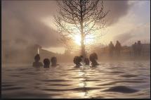 **\*NEW* Swimming at The Secret Lagoon**: Secret Lagoon natural hot springs are located in the small village called Fludi, and are in the Golden Circle area. The pools natural surroundings and steam rising into the air gives the place a magical feeling. The warm water holds 38-40 Celsius all year. In the whole area there are several geothermal spots and a little Geysir which, erupts every 5 minutes.

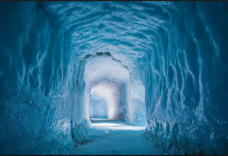 **\*NEW*Lanjokull Ice Caves**: departing from the Lanjokull glacier edge and we journey to one of the world’s greatest wilderness where you will be able to explore the incredible ice cap glacial environment. This will enable us to explore around **on** and **within** the giant 953 sq/km glacier. This isn’t your average Iceland tour, it is a once in a lifetime adventure to Iceland’s most significant new attraction as we will see the beautiful blue ice at the heart of an Ice Cap glacier; located high on Europe’s second largest glacier Langjokull. Experience the awesome ice cap glacial environment by taking a ride in a monster 8 wheel drive glacier truck and bear witness to the effects of global warming.

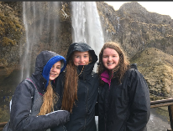 **South Shore Day**: visit the 200ft high Skógafoss waterfall and Selijalandsfoss waterfall to compare the differing formations. Study coastal processes and wave characteristics along the black volcanic beaches and basalt-columned cliffs of the Dyrhólaey coast.

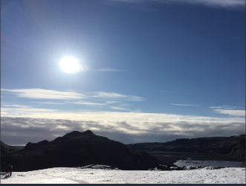**Glacier Walk on Sólheimajökull**: A guided glacier walk is a great glacier adventure where you can try for yourself how it feels to walk on Ice. All participants must have suitable walking boots. Students are kitted out with helmets, crampons and ice axes. Whilst on the walk across the ice of the Sólheimajökull Glacier, we get detailed explanations about glacier formations from specially trained guides and discover ice cave tunnels and an amazing glacier lagoon.

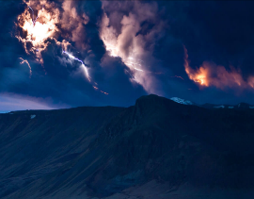 **\*NEW* Lava Centre**: The Lava Centre is an interactive, high-tech educational exhibition depicting volcanic activity, earthquakes and the creation of Iceland over millions of years. Attractions include: **Volcano Corridor, Geology Globe, Earthquake Corridor, The Fiery Heart of Iceland, Lava Corridor, Intro to Volcanology, Ash Corridor and is the site of actual Volcanoes.**

*All visits in Iceland are weather dependant.* Information kindly provided by NST