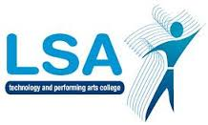
LSA ENGLISH DEPARTMENT

L

Y10 Assessment Summary for Parents: GCSE English Language & Literature

Date | Topic/Task  (and % weighting to that assessment) | Type of Assessment
Assessment 1  Sept - Nov | AIC/LOTF character essay (50%)  Fiction comprehension (50%)  (0% of whole year assessment) | Formal assessment of literature  Formal assessment of language
Assessment 2  Dec - April | Magazine article (50%)  Macbeth essays (50%)  (0% of whole year assessment) | Formal assessment of language  Formal assessment of literature
Summative  Assessment  April - June | Poetry comparison  Short story (50%)  Fiction comprehension (50%)  (100% of whole year assessment) | Formal assessment of literature  Formal examination of language  Formal examination of language

- Summer examination counts towards 100% of summative assessment to reflect the GCSE examination

