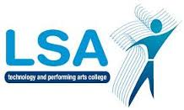
LSA ENGLISH DEPARTMENT

L

Y7 Assessment Summary for Parents 2016-7
Date | Topic/Task | Type of Assessment
Assessment 1  Sept - Dec | Magazine article (5%)  Non-fiction comprehension (10%)  (15% of whole year assessment) | Formal assessment  Skills Practice assessment
Assessment 2  Dec - March | Treasure Island letter (15%)  Treasure Island fiction comprehension (10%)  Long John Silver character assessment (10%)  (35% of whole year assessment) | Skills Practice assessment  Formal assessment  Skills Practice assessment
Summative  Assessment  April - July | Poetry anthology: response (30%)  Non-fiction writing (20%)  (50% of whole year assessment) | Examination  Examination
- nb: timings are subject to variation if the class is split between two teachers

